**SIYEENOVE Leonardo R3 Board for Arduino**

# Overview

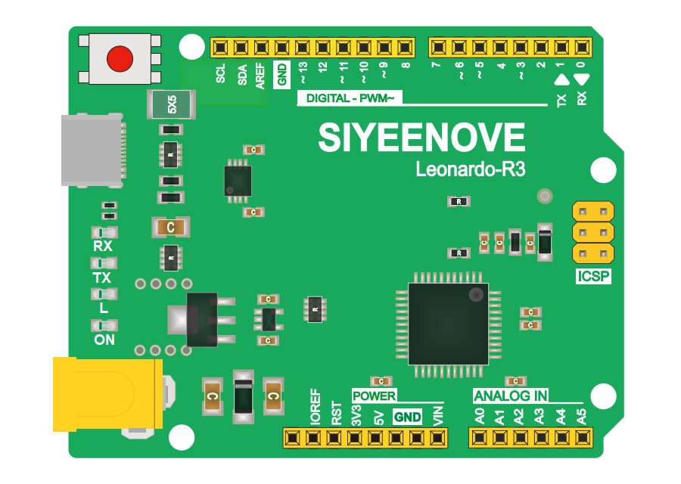

SIYEENOVE Leonardo R3 Board is fully compatible with Arduino. Its main chip is ATmega32u4, which has 23 digital input and output ports, 7 PWM ports and 12 analog input ports.

The Leonardo differs from all preceding boards in that the ATmega32u4 has built-in USB communication, eliminating the need for a secondary processor. This allows the Leonardo to appear to a connected computer as a mouse and keyboard, in addition to a virtual (CDC) serial / COM port.

We changed the micro USB port to a type-C USB port, making it more convenient to use and more compatible. To make it easier to fix the control board to other devices, the control board comes with 4 fixing holes with a diameter of 3mm.

# Specifications

|  |  |
| --- | --- |
| **Board** | |
| Name | Leonardo R3 |
| SKU | A1D0000 |
| **Microcontroller** | |
| AVR ATmega32u4 | |
| **USB connector** | |
| Type-C USB (USB-C) | |
| **Pins** | |
| Built-in LED Pin | 13 |
| Digital I/O Pins | 23 |
| Analog input pins | 12 （10-bit） |
| PWM pins | 7 |
| **Communication** | |
| UART | Yes |
| I2C | Yes |
| SPI | Yes |
| **Power** | |
| Input voltage (nominal) | 7-12V |
| DC Current for 3.3V Pin | 50 mA |
| DC Current for 5V Pin | 500 mA |
| DC Current per I/O Pin | 5V/40mA |
| Power Supply Connector | Barrel Plug（DC-005） |
| **Clock speed** | |
| Processor | ATmega32U4 16 MHz |
| **Memory** | |
| ATmega32U4 | 2.5KB SRAM, 32KB FLASH, 1KB EEPROM |
| **Dimensions** | |
| Weight | 20 g |
| Width | 53.3 mm |
| Length | 68.6 mm |

# **Pin Description**

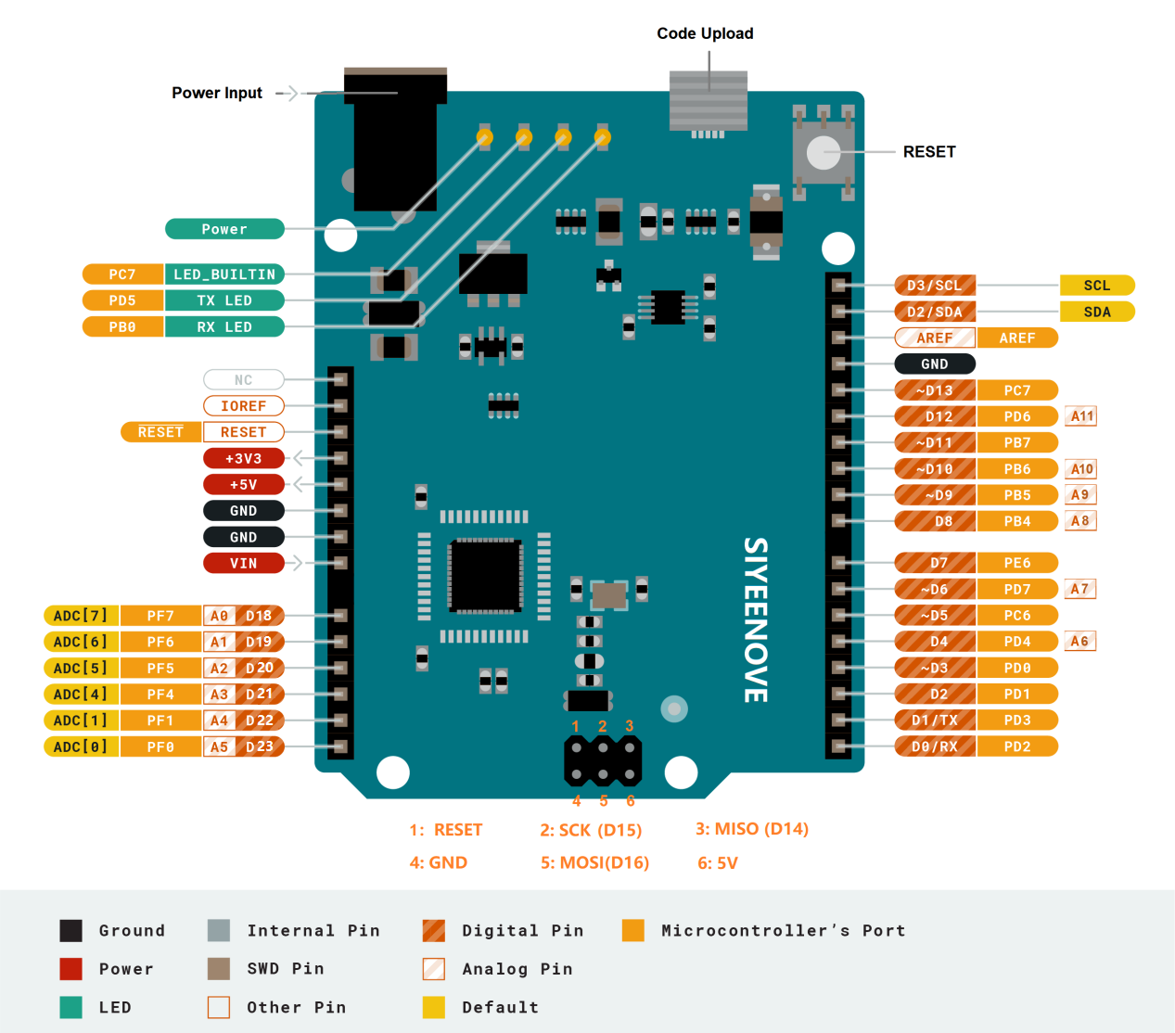

# Special Interface Description

|  |  |
| --- | --- |
| Digital I/O pins | D0-D13, D14(MISO), D15(SCK), D16(MOSI), D18-23(A0-A5) |
| Analog input pins | A0-A5, A6(D4), A7(D6), A8(D8), A9(D9), A10(D10), A11(D12) |
| PWM pins | D3, D5, D6, D9, D10, D11, D13 |
| External interrupt pins | D3(Interrupt0), D2(Interrupt1), D0(Interrupt2), D1(Interrupt3), D7(Interrupt4) |
| UART | D0(RX), D1(TX) |
| I2C | D2(SDA), D3(SCL) |
| SPI | ICSP interface, D14(MISO), D15(SCK), D16(MOSI) |
| “L” LED | There is a built-in LED on digital pin 13. When the pin is high, the LED is on. When the pin is low, the LED is off. |

# 5. Install Arduino IDE

You can download Arduino IDE by visiting the following website: <https://www.arduino.cc/en/software>

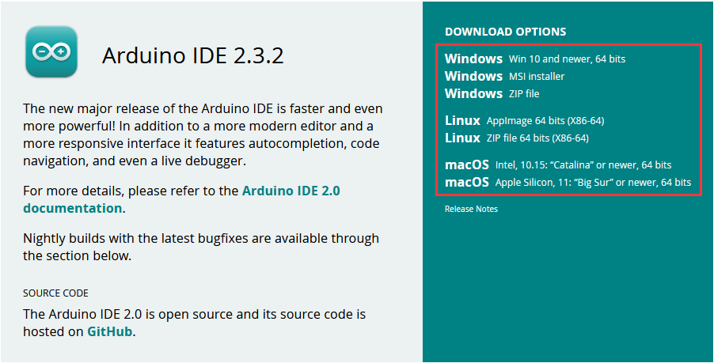

Here we click ”Windows Win 10 and newer, 64 bits" .

You can also select the old version of IDE you need at the bottom of the page.

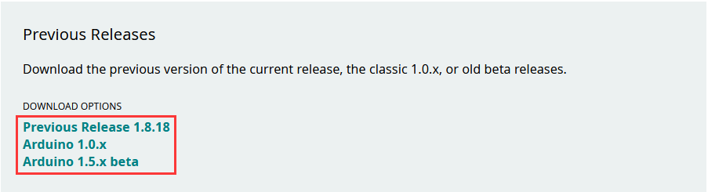

It is recommended to use Arduino IDE 2.x.x version!

# Install USB driver files

Drivers should be automatically installed plugging with an USB cable the board to your PC, but with some version of the Windows operative system (like Windows 7, Vista and 10) it can happen that your board won't be recognized and you will get the message Unknown USB device. It is so necessary to manually install them following the guide [Manually install Drivers on Windows](https://arduino.cc/en/Guide/DriverInstallation).

If you are using Windows 7, Vista and 10 systems, you need to install the old version of Arduino IDE, download address:<https://www.arduino.cc/en/software>

The following instructions are for Windows 7, Vista and 10. They are valid also for Windows XP, with small differences in the dialog windows.

Plug in your board and wait for Windows to begin its driver installation process. If the installer does not launch automatically, navigate to the Windows “**Device Manager**” (Start>Control Panel>Hardware) and find the Arduino Leonardo listing. Right click and choose **Update driver**.

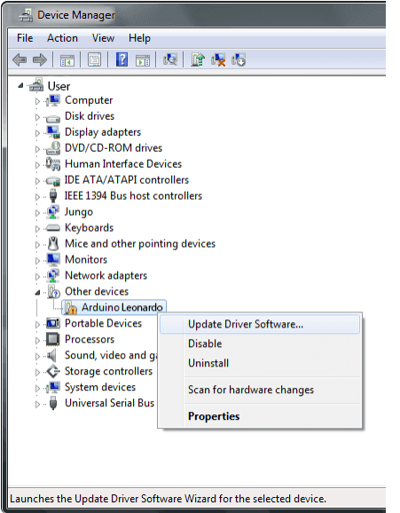

At the next screen, choose "**Browse my computer for driver software**", and click **Next**.

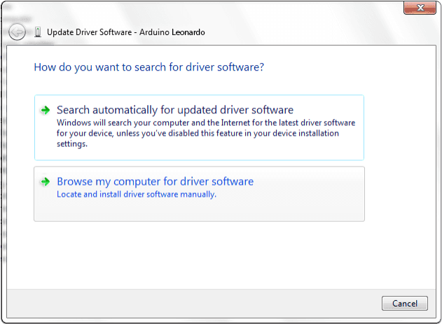

Click the ”**Browse...**” button. Another dialog appears: navigate to the folder with the Arduino software that you just downloaded. Select the ”**drivers**” folder an click ”**OK**”, then click”**Next**”.

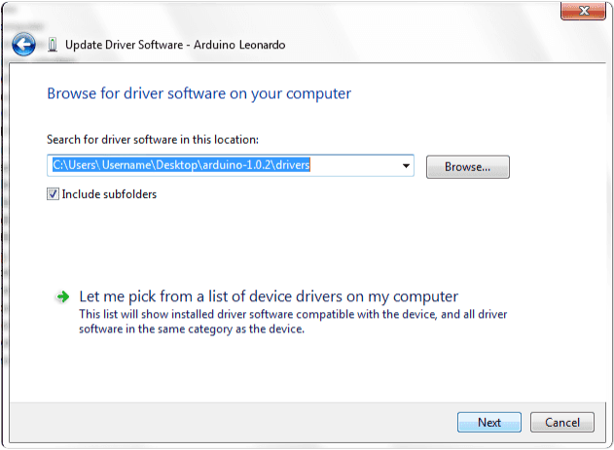

You will receive a notification that the board has not passed Windows Logo testing. Click on the button ”**Continue Anyway**”.

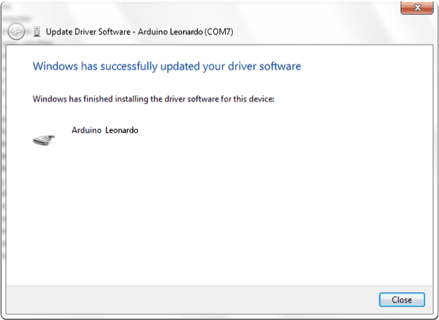

After a few moments, a window will tell you the wizard has finished installing software for Arduino Leonardo. Press the ”**Close”** button.

# 7. Arduino IDE settings and toolbar introduction

The Arduino IDE 2 features a new sidebar, making the most commonly used tools more accessible.

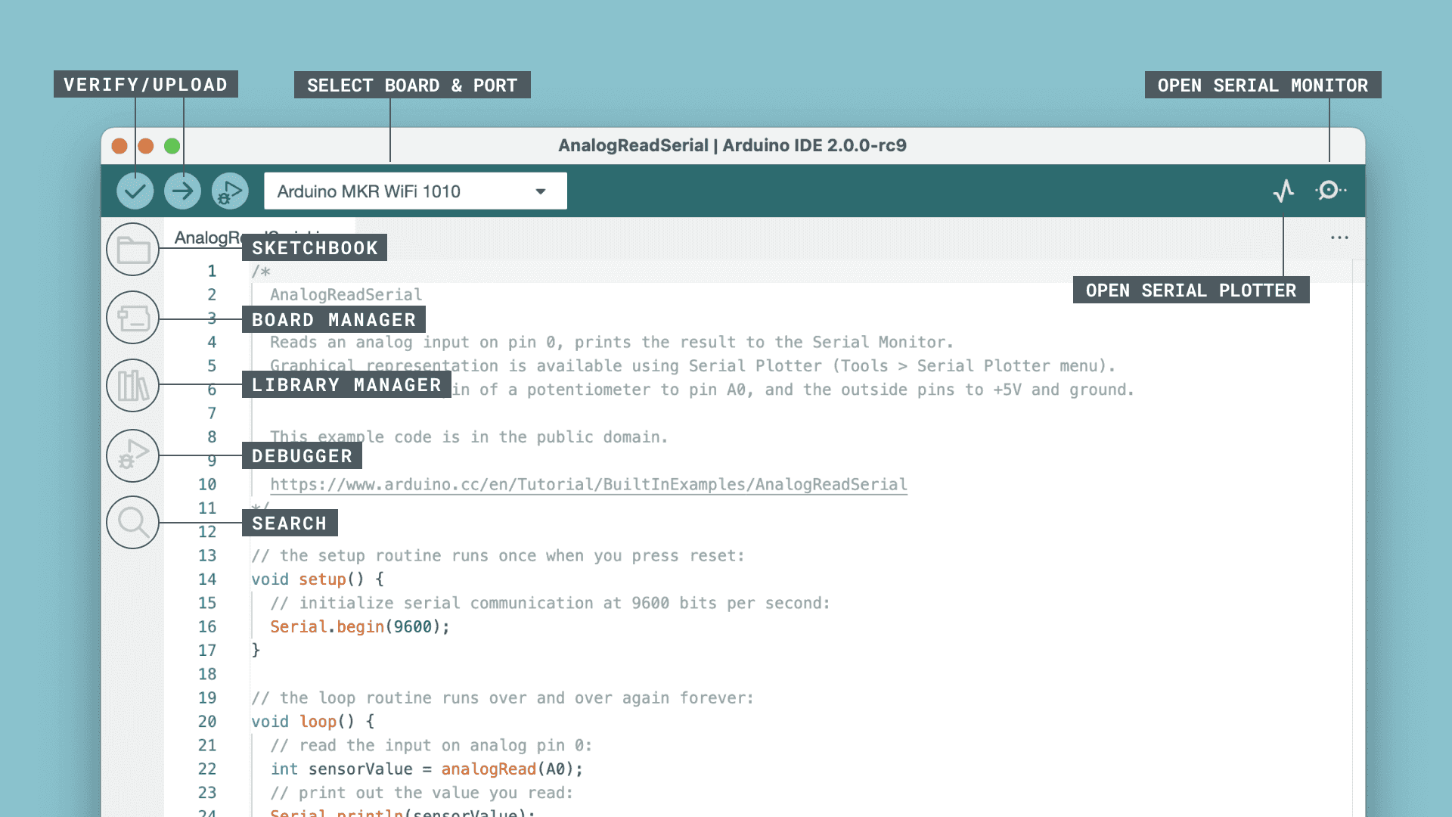

**▶Verify / Upload** - compile and upload your code to your Arduino Board.

**▶Select Board & Port** - detected Arduino boards automatically show up here, along with the port number.

**▶Sketchbook** - here you will find all of your sketches locally stored on your computer. Additionally, you can sync with the [Arduino Cloud](https://cloud.arduino.cc/), and also obtain your sketches from the online environment.

**▶Boards Manager** - browse through Arduino & third party packages that can be installed. For example, using a MKR WiFi 1010 board requires the Arduino SAMD Boards package installed.

**▶Library Manager** - browse through thousands of Arduino libraries, made by Arduino & its community.

**▶Debugger** - test and debug programs in real time.

**▶Search** - search for keywords in your code.

**▶Open Serial Monitor** - opens the Serial Monitor tool, as a new tab in the console.

More references:<https://docs.arduino.cc/software/ide-v2/tutorials/getting-started-ide-v2/>

# 8、Open the Blink example

Now that you've set up your IDE let's make sure your computer can talk to the board, it's time to make sure you can upload a program. To do that let's open the LED blink example sketch: **File > Examples > 01.Basics > Blink**.

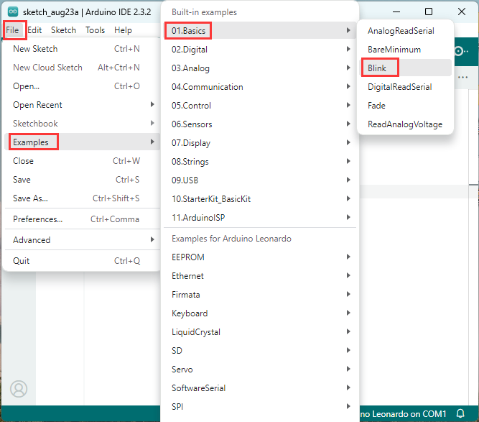

You'll need to select your board in the **Tools > Board** menu:

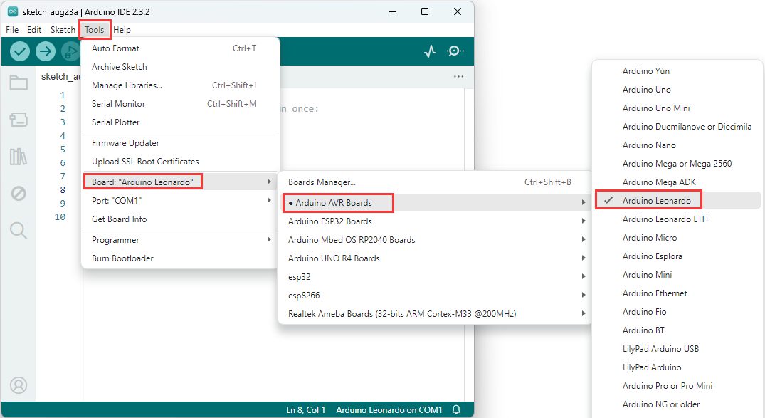

Select the serial device of the board from the **Tools > Serial Port** menu.

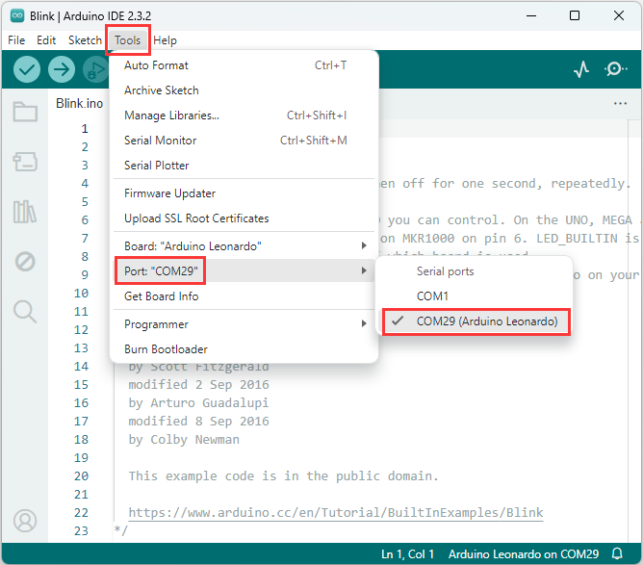

Click the ”**Upload**” button in the upper left to load and run the sketch on your board:

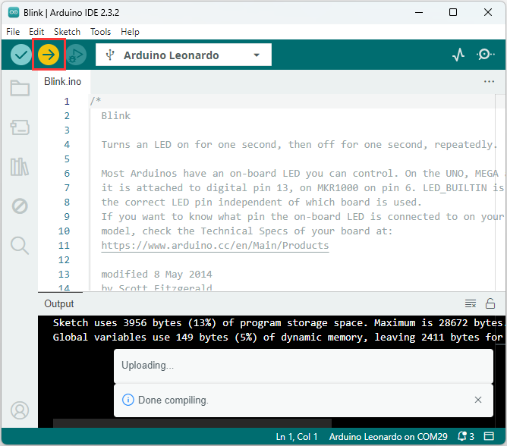

After the compilation and upload process, you should see the message Done Uploading and the built-in LED of the board should start blinking.

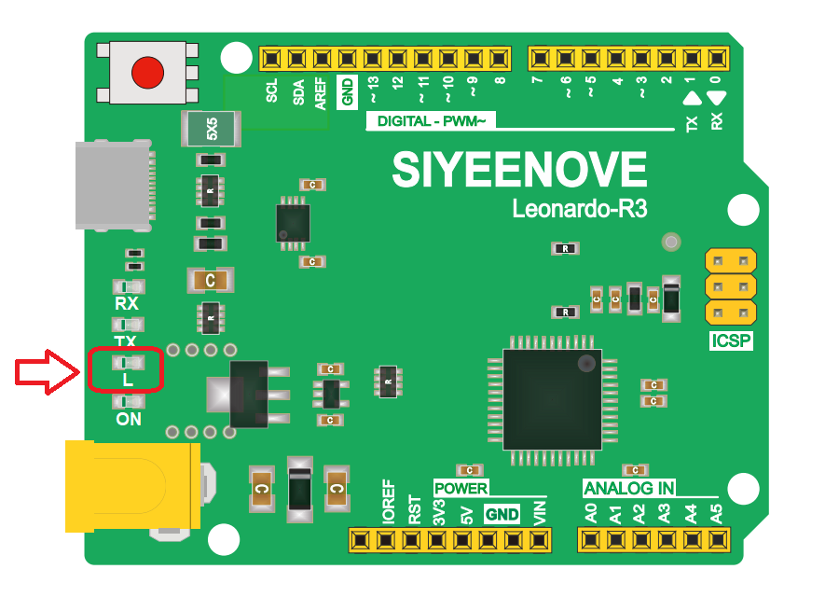

# 9、Contact us

If you encounter technical problems or want to share your ideas and opinions with us, please contact us at any time.

✉[siyeenove@outlook.com](mailto:jex-spt@outlook.com)

 [http://siyeenove.com](http://cokoino.com)